Canyon Lake Creek (addition)
Tributary to AWC Lake: 247-41-10200-2053-3205-4069-0010 (Canyon Lake, Canyon Lake Creek).
Quad D-5, Southcentral Region
8/23/2025
Field Summary/Comments: Conducted minnow trapping at the following three locations of tributary to AWC listed Canyon Lake: (61.891079, -151.632668), (61.890953, -151.633068), (61.891079, -151.632668). Minnow traps placed at ~50 ft spacing along slow, bog-adjacent section of the creek. Clear water, sandy/muddy stream bed turning to riffles and gravel upstream and downstream of the sampled pool sections.
Juvenile Coho Salmon observed in all three traps, with 19x Coho captured in trap #1, 25x in #2, and 17x in #3. All fish were measured and released.
A foot and aerial survey shows the extent, and continued development/clearing of a privately constructed road directly adjacent to the streambank; Canyon Lake Creek is being crossed with heavy machinery tracks directly upstream of this new AWC extension. There is an additional previously noted fish passage barrier at the inlet of creek into AWC listed Canyon Lake (sand bags placed to block inlet of creek into lake) in 2024.
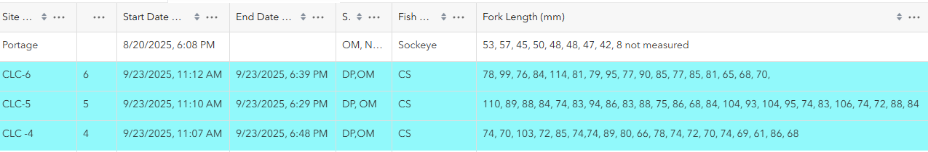
Field Data

Fig 1. Survey 123 data* from the three minnow traps set at Canyon Lake Creek upstream of Canyon Lake (labeled CLC-4, CLC-5, & CLC-6) highlighted in blue.
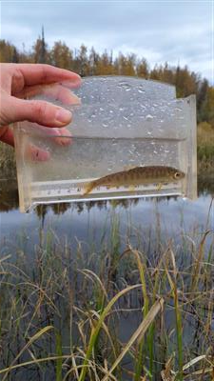
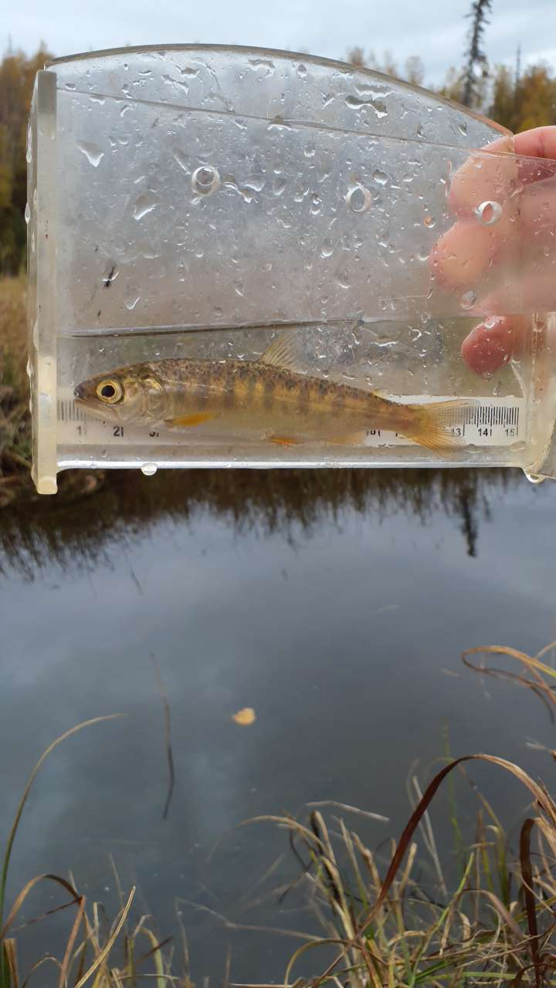
Fig 2. Two of the juvenile Coho Salmon captured at minnow trapping site.
*Please see the three attached survey forms for additional information, including survey details, more photos of the site, all captured fish, and maps for each individual trap.

